BAR CHARTS

1. the bar chart below reveals quickly which product *Sub-Categories* have high product sales and which do not, allowing us to make decisions about how certain products are performing. Below bar is showing descending order.

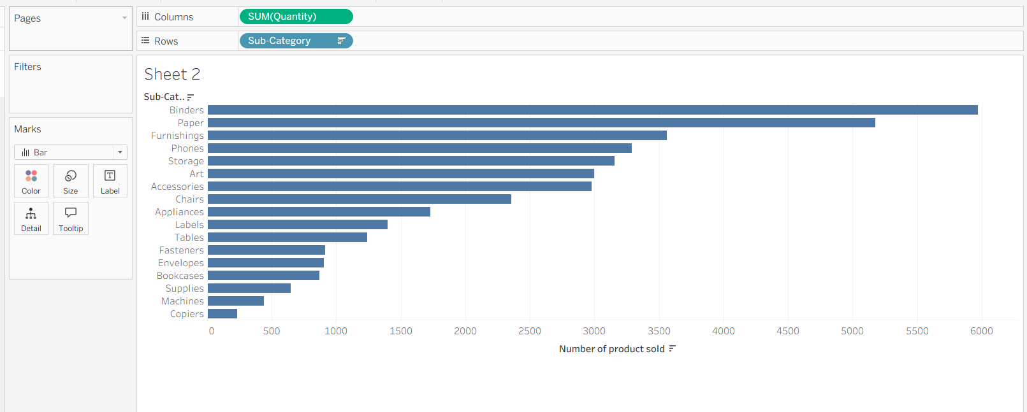

1. I built a bar chart that compares the number of sales for all of the product *Sub-Categories*. By ascending order

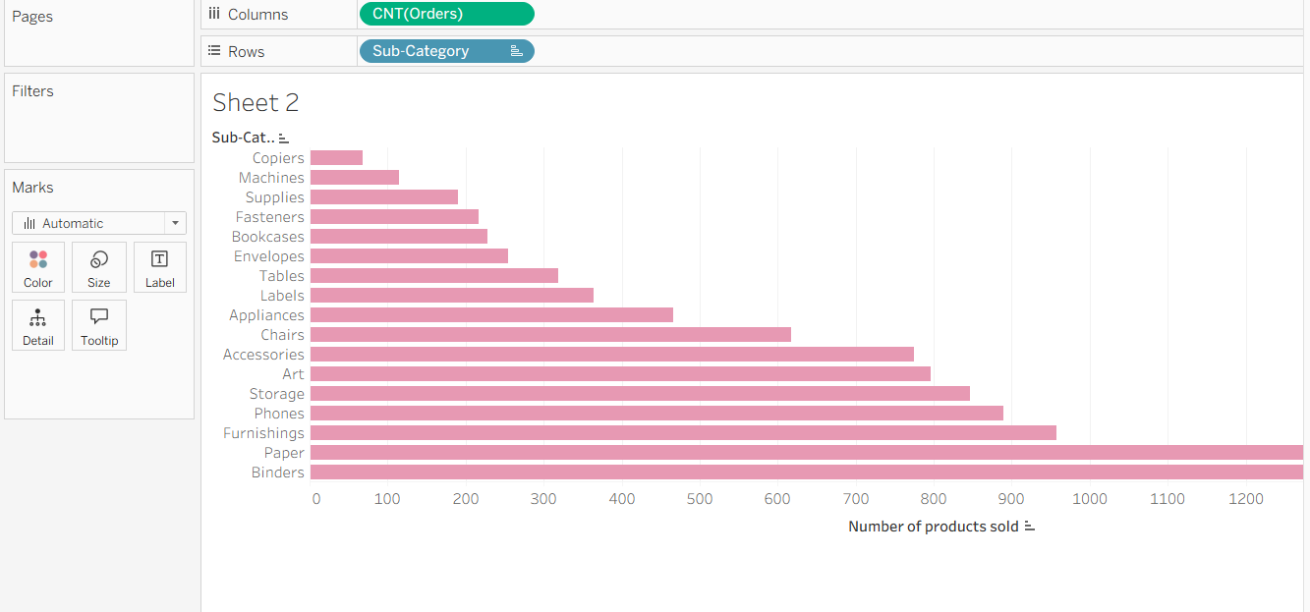

1. We are showing the profit and category comparison by vertical bar charts. We can identify which category has highest and lowest profit.

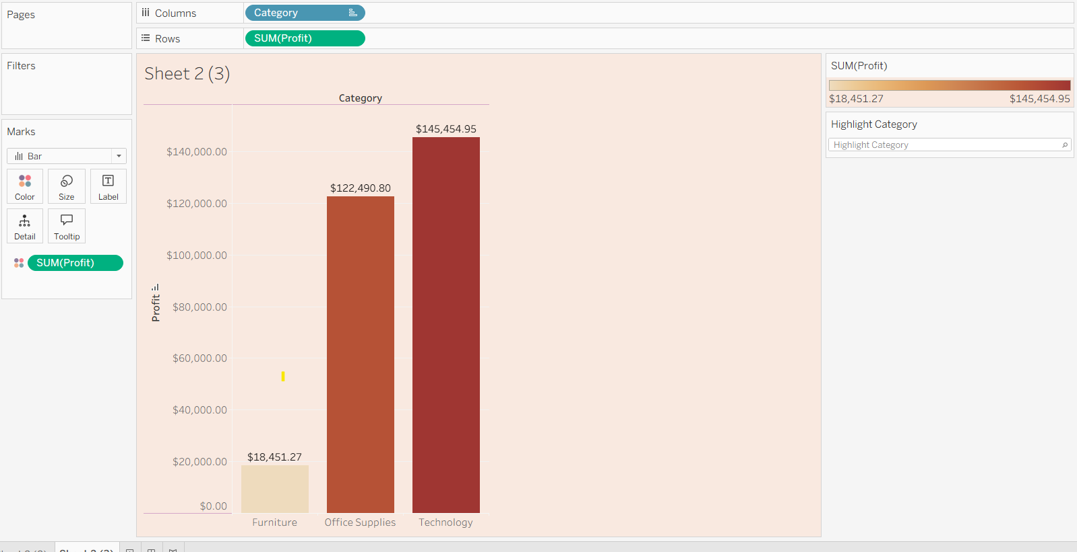

1. Below bar chart is showing the sales value by comparing the category and segment.

I have prepared the data with 3 different visualizations:

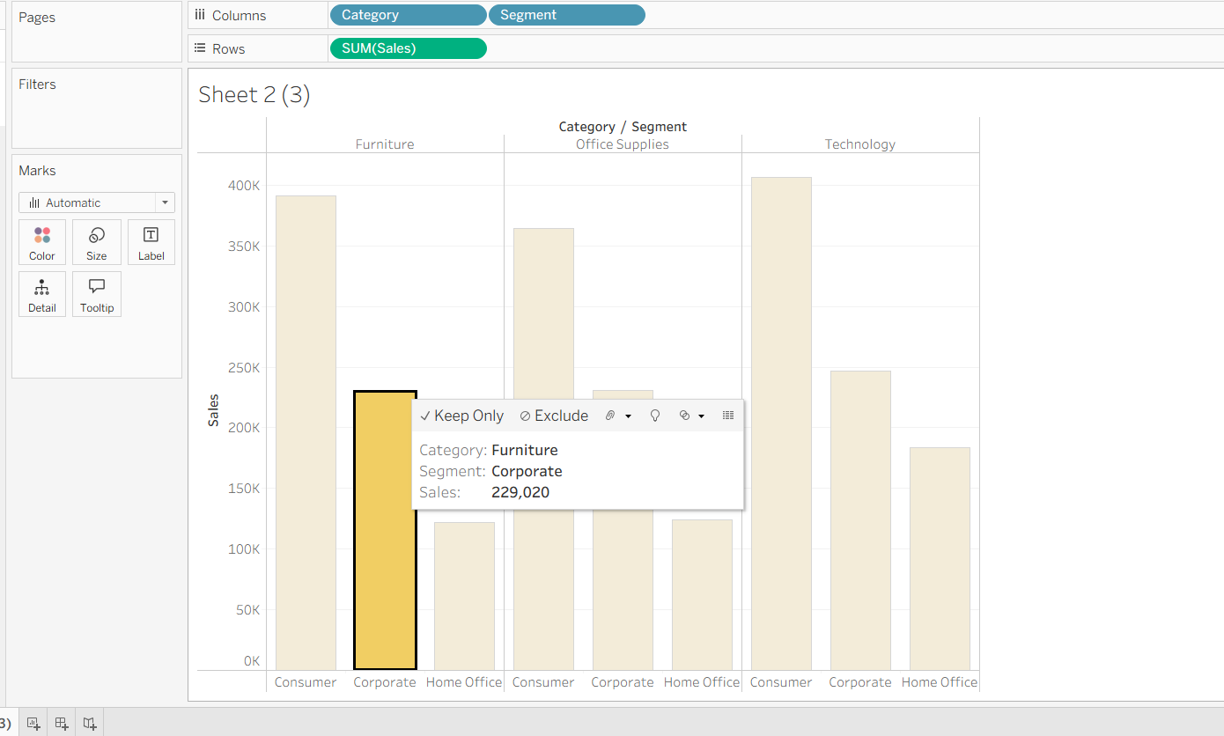

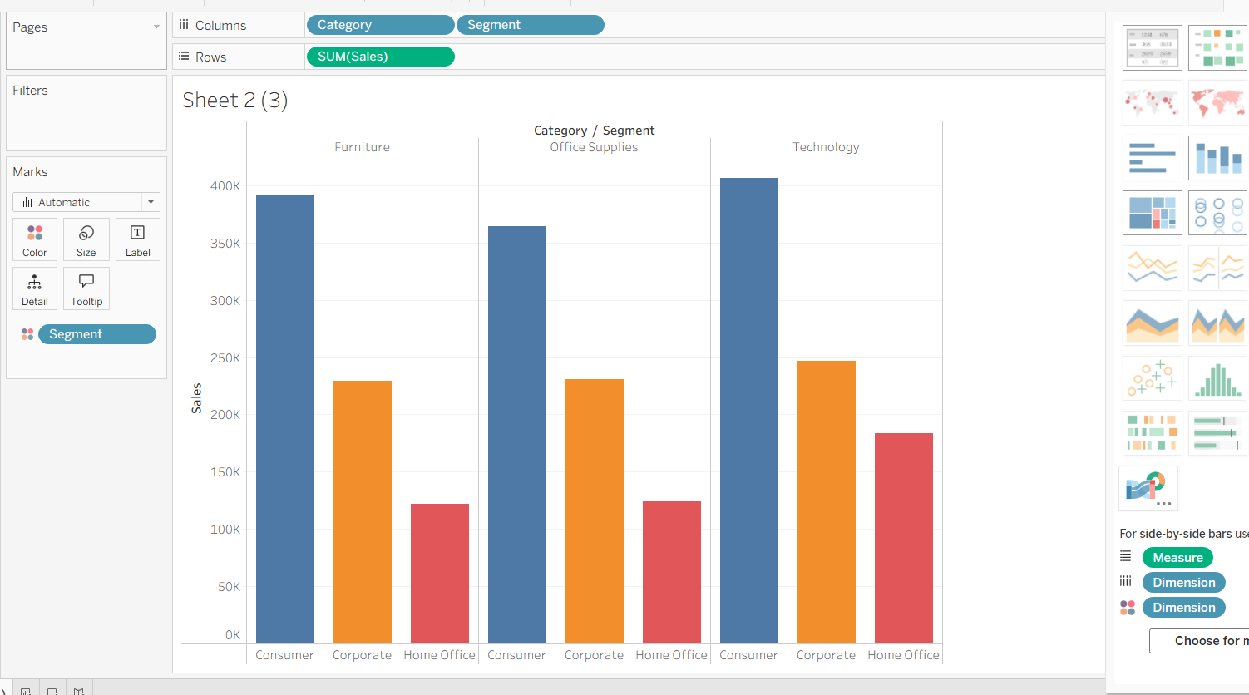

We can easily identify which category under what segment has the highest and lowest sales

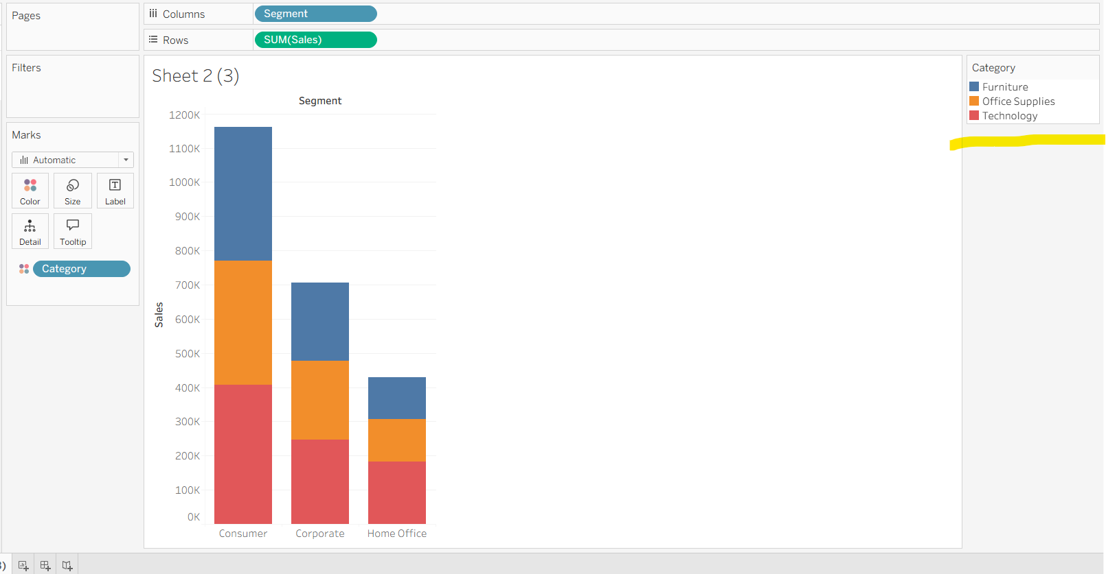

Here we can identify the sales based on the segment and based on the color for the category